

A Minor project report on

KLE Technological University, Hubballi

-

580031

Onion Detopping Machine
Related to the course: - Minor Project (24EMEW301)

Submitted By

Sl. No. | Name | Roll No | USN
1. | Abhinav Hegde | 203 | 01FE22BME006
2. | Kirangoud Biradar | 230 | 01FE22BME065
3. | Varun Teli | 233 | 01FE22BME118
4. | Darshan L | 234 | 01FE23BME461
5. | Sameer Chitnis | 237 | 01FE22BME115
6. | Akshay Kulkarni | 245 | 01FE23BME476
Under the Guidance of

Prof. Sridhar M

2024-25



CERTIFICATE

This is to certify that Minor Project entitled “Onion Detopping Machine” submitted by 6th semester Division B Team 08 to the KLE Technological University, Hubli-580031, towards partial fulfillment for the award of the degree of Bachelor of Engineering is a bona-fide record of work carried out by them under our supervision. The contents of the project report, in full or in parts, have not been submitted to any other institute or university for the award of any degree or diploma.

Prof. Sridhar M Dr. G. U Raju
Guide Head of department

Name of the Examiners Signature with date

1.

2.

ACKNOWLEDGEMENT
The successful completion of any task would be incomplete without mentioning the people who made it possible and whose guidance and encouragement have made our efforts successful.
At the outset, we would like to express our deep sense of gratitude to our guide, Prof. Sridhar M, for making this project report successful through their invaluable guidance at every stage of the project report.
We also thank HOD Dr. G U Raju for his encouragement in undertaking the task of this project.
We express our sincere regard and gratitude to our project coordinators, Prof Sridhar M, Prof.
Praveen P, and Prof Ashwin, School of Mechanical Engineering, KLE Tech, Hubli

We are also thankful to all faculty members of the Mechanical Engineering Department of KLE Technological University, for helping us directly or indirectly in different stages of our project work.

Contents:
1. Refined problem statement |  | Page No.
1.1 | Identifying end users (Customers) | 5-7
1.2 | Requirements List | 8
2. Product benchmarking
2.1 | Studying and exploring competitive products | 8
2.2 | Research papers | 9
3. Design Specifications
3.1 | Objectives | 10
3.2 | Constraints | 10
3.3 | Objective tree (affinity diagram) | 11
4. Concept generation
4.1 | Defining Functions | 12
4.2 | Morphological chart | 12
4.3 | Generating design alternatives | 13-15
4.4 | Selecting the best alternatives (Pugh chart) | 16
5. Design
5.1 | 3D Model | 17-22
5.2 | Assembly models | 23
5.3 | 2D drawing | 17-22
5.4 | Design Calculations and Analysis | 23-25
6 Prototype Planning
6.1 | Raw materials | 26
6.2 | Bill of Materials | 26-27
6.3 | Joining techniques/ methods | 27
6.4 | Flow Chart | 27
6.5 | Circuit Block Diagram | 28
7 Prototyping
7.1 | Fabrication Pictures | 28-29
7.2 | Photos | 29-30
7.3 | Conclusion | 30

Phase 1
1.1 Refined problem statement
Customer: Chandarshekhar Interviewer(s): Sameer C Date: 10-03-2025

Question/Prompt | Customer Statement | Interpreted Need/ Expectations
Typical uses | Used post-harvest to remove tops from onions before packing. | Machine should save time and labor in post-harvest processing.  Precision in cutting needs to be retained in the new design.  The machine should be faster and reduce physical effort.  Easy to operate and provides uniform output.
Likes the current methods followed  (traditional techniques) | Manual cutting gives cleaner cuts and avoids damage to onion.
Dislikes the current methods followed  (traditional techniques) | It is too time-consuming and labor-intensive.  Semi-automatic solution with consistent cut length.
Suggested
Improvements

Customer: Hussain Interviewer(s): Akshay K Date: 12-03-2025

Question/Prompt | Customer Statement | Interpreted Need/ Expectations
Typical uses | Mainly used during peak harvest season in bulk quantities. | The machine must handle large volumes efficiently.
Prefer a solution that works manually or with low power.
Speed and productivity improvement required.
Flexible power options; suitable for field use.

Likes the current methods followed  (traditional techniques) | No dependency on electricity; works in remote areas.  Manual cutting slows down the supply chain.
Dislikes the current methods followed (traditional techniques)
Suggested  Improvements | A pedal-based or battery-operated model.

Customer: Hegde Printing Interviewer(s): Kirangoud Date: 08-03-2025

Question/Prompt | Customer Statement | Interpreted Need/ Expectations
Typical uses | For both domestic and export market preparation. | The finish quality must match export standards.  Maintain high quality of detopping with minimal damage.  Reduce dependency on skilled labor.  Should handle different sizes without loss in quality.
Likes the current methods followed  (traditional techniques) | High accuracy in detopping by experienced workers.
Dislikes the current methods followed (traditional techniques) | Output depends on labor skill and availability.
Suggested  Improvements | Adjustable blade height based on onion size.

Customer: Kartik Interviewer(s): Abhinav H Date: 12-03-2025

Question/Prompt | Customer Statement | Interpreted Need/ Expectations
Typical uses | Pre-processing before sorting and grading. | Machine should integrate easily with grading process.  Add inspection possibility or ensure clean output.  Reduce wastage, improve consistency.  Ergonomic design and minimal handling required.
Allows visual inspection of each onion during cutting.

Too much waste and inconsistent cuts.

Likes the current methods followed
(traditional techniques)
Dislikes the current methods followed (traditional techniques)
Suggested  Improvements | Transparent chute or tray for quick checking.

1.2 Requirements List: -
Customer | Requirements
1 to 6 | A Semi-automatic or automatic operated efficient onion detopping machine
 | Ability to sort onions based on onion size
 | It would be sturdy enough for long term use in commercial
 | Easy for maintenance
 | It would be sturdy enough for long term use in commercial
 | Smooth manual operations
 | Low cost, durable and easy to use

Phase 2
Product Benchmarking
2.1 Studying and exploring competitive products
Products (Images or name) | Specifications | Cost | Advantage | Limitations | Functions
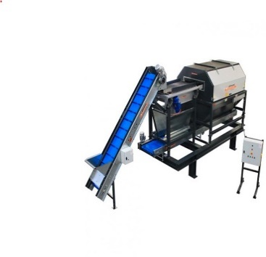 | - Detops onions by cutting top ends  - Manual feed with semi-automatic cutting  - Stainless steel blades  - Motor-driven cutting unit | Approx. ₹35,000 – ₹50,000 | - Fast and consistent detopping  - Low maintenance  - Simple to operate | - Manual feeding needed  - Limited to one onion size per setting | - Cuts onion tops  - Prepares onions for peeling and further processing
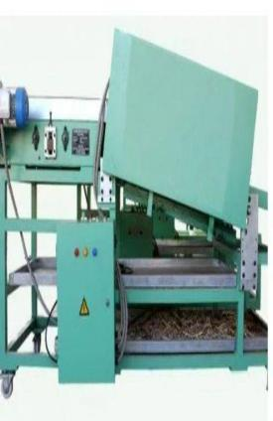 | - Fully automatic detopping system  - Conveyor-based feed  - Adjustable blade for multiple sizes  - PLC-based control panel | Approx. ₹1,20,000 – ₹1,50,000 | - High efficiency and throughput  - Supports varying onion sizes  - Reduces labor cost | - Higher cost  - Needs trained operator for PLC controls | - Cuts onion tops and tails  - Auto-feeds and aligns onions  - Prepares for next processing stage

2.2 Research papers
Paper Name/Authors | Information
Rathinakumari A.C. and Senthil Kumaran G.  ICAR-Indian Institute of Horticultural Research, Bengaluru – 560 089, Karnataka. India  Corresponding author E-mail : CAROLINA.KUMARI@icar.gov.in | Onion is the one of the important vegetable crops cultivated in India. Multiplier type onion is one among the three major types of onions. Tamil Nadu accounts for five per cent of country’s area under onion and more than 70 per cent of the area is cultivated by small onion (Allium cepa var. aggregatum). Around 90 per cent of country’s multiplier onion is produced from Tamil Nadu. Detopping is one of the steps in the on-farm processing carried out after harvest. Presently this is done manually by farm women. Individual onions are picked and detopping is done by using sickle. This operation is time consuming and highly drudgery in nature. An Onion detopping machine to remove the foliage after harvest was designed and developed in the present study. This machine has a capacity of 370 kg/h against 30 kg/h manual practice and works with an efficiency of 98%. The unique design of the detopper is that it is suitable for all sizes of onions. Also, the cluster is intact after detopping, which is very important requirement.
Lokesh Kumawat¹& Hifjur Raheman¹  Laboratory Investigations on Cutting Torque and Efficiency for Topping of Onion Leaves Using Wire-Type Rotary Unit | Methods A laboratory setup comprising a rotary cutting unit with wire as working element was developed to measure the torque required to cut onion leaves along with topping efficiency. The developed set up simulated the topping process of an onion topper in actual field condition which helped to analyze the effect of different operational parameters (rotational speeds of cutting unit, cutting width, and forward speed of the machine) on cutting torque and topping efficiency. Experimental data obtained from this setup revealed that the rotary speed of the cutting unit and forward speed of the harvester should be below 1800 rpm and 1.2 km h⁻¹, respectively; otherwise, it may damage the onion leaves with poor topping efficiency. Mature onion crop (Pusa Red) at 110 days after transplanting were chosen as experimental samples. The range of cutting speed, cutting width, and forward speed were 1200–1800 rpm, 300–600 mm, and 0.22–0.33 m s⁻¹, respectively.

Phase 3
3.1 Design Specifications
 | Objectives
Easy to operate | User-friendly design
Efficient leaf cutting | Low power consumption
Safe to use | Easy to clean and maintain
Cost-effective | Easy loading and unloading of onions
Durable and long-lasting | Compact size

3.2 Constraints
Constraints
Soil Conditions: Performance may vary with different soil types, which can affect digging, efficiency and traction.
Onion Size and Variety: The machine must handle different onion sizes and shapes without damaging them, which can be challenging for a fixed design.
Cost Limitation: The machine must be affordable for target users, limiting high-end components or automation.
Power Source: Dependence on available power sources (manual, electric, or tractor-PTO driven) could limit functionality in remote or off-grid areas.
Field Layout: Irregular field layouts, narrow rows, or small plot sizes may restrict machine efficiency.

3.3 Objective tree (affinity diagram)

O# | Objectives | First-level objectives | Second-level objectives | Third-level objectives
1 | Reduce man power |  | ★
2 | cost reduction. |  | ★
3 | Improve the design of the setup |  |  | ★
4 | Operate at high speed |  | ★
5 | Minimize power consumption | ★
6 | Making it Eco-Friendly | ★
7 | Making it User Friendly. |  | ★
8 | Suitable for small and medium sized farms | ★
9 | Easy to operate |  | ★
10 | Safety | ★
11 | Efficient control of each function. |  | ★

Phase 4
4.1 Functions: -
Si. | Functions | Sub Functions (optional)
1 | Cut onion leaves efficiently using a rotary blade | —
2 | Hold onion securely during cutting. | —
3 | Rotate blade via electric motor. | —
4 | Sort onions based on size. | —
5 | Start/stop machine using control panel | —
6 | Easy to clean, portable, and simple to operate. | —
7 | Blade guard and stable base for safety. | —
8 | Emergency switch for instant shutdown. | —

4.2: - Morphological Chart
Functions ▼ | Means► | Means 1 | Means 2 | Means 3 | Means 4
Machine Type |  | Manual | Semi Automatic | Fully Automatic | Fully Automated with Robots
Cutting Mechanism |  | Rotating blade | Circular cutter | Pneumatic | Laser Cutter
Feeding System |  | Manual Feed | Conveyor Belt | Vibrating Table | Automatic Hopper Feed
Detopping Mechanism |  | Single Cut | Multiple Parallel Cuts | Rotating Blades | Horizontal and Vertical Cut Combo
Waste Disposal |  | Manual Collection | Conveyor Belt to Waste Bin | Pneumatic Waste Removal | Automatic Waste Compaction
Machine Material |  | Stainless Steel | Mild Steel | Plastic and Steel Hybrid | All Stainless Steel
Power Source |  | Electric Motor | Gas Engine | Electric Motor with Battery backup | Solar and Electric
Size of Onions |  | Fixed Size | Adjustable to Onion Size | Variable size detection | Automatic Size Detction
4.3 Concept Generation
Design No.01

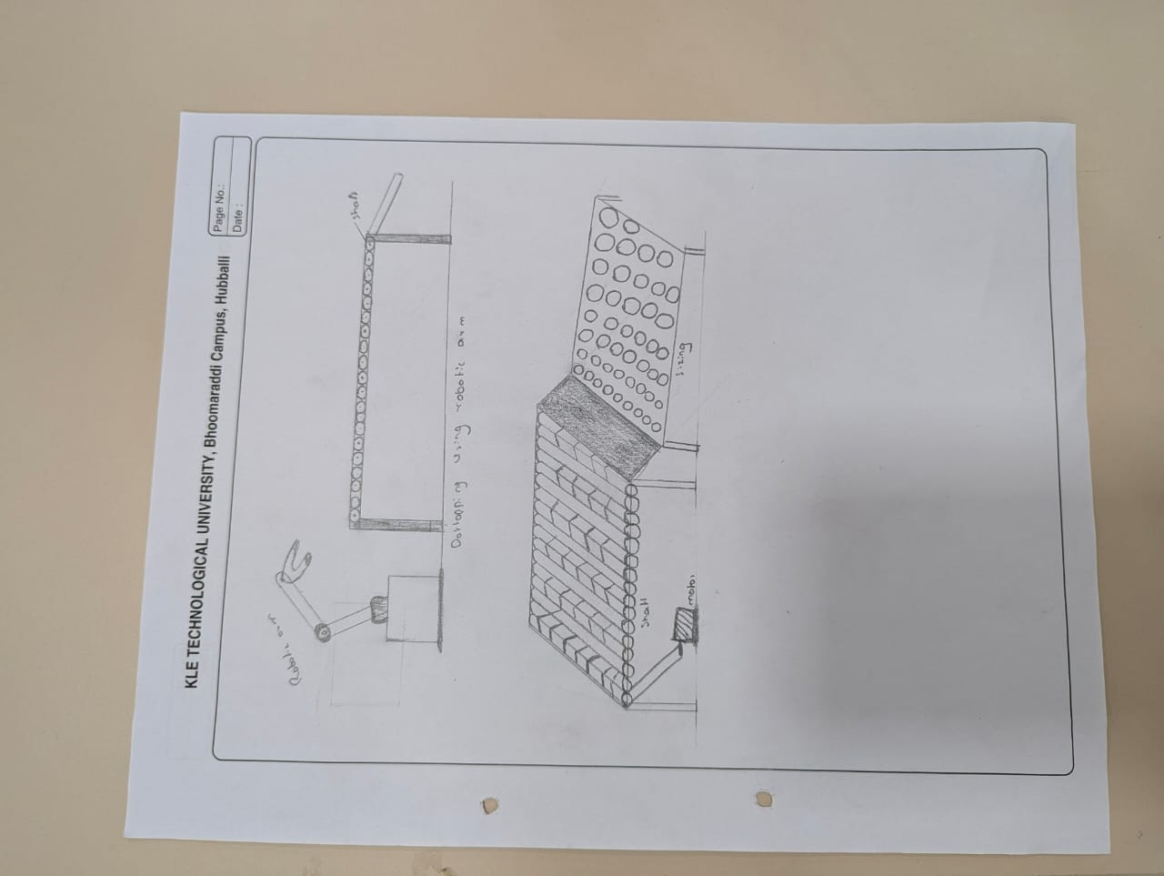

Design No: - 2
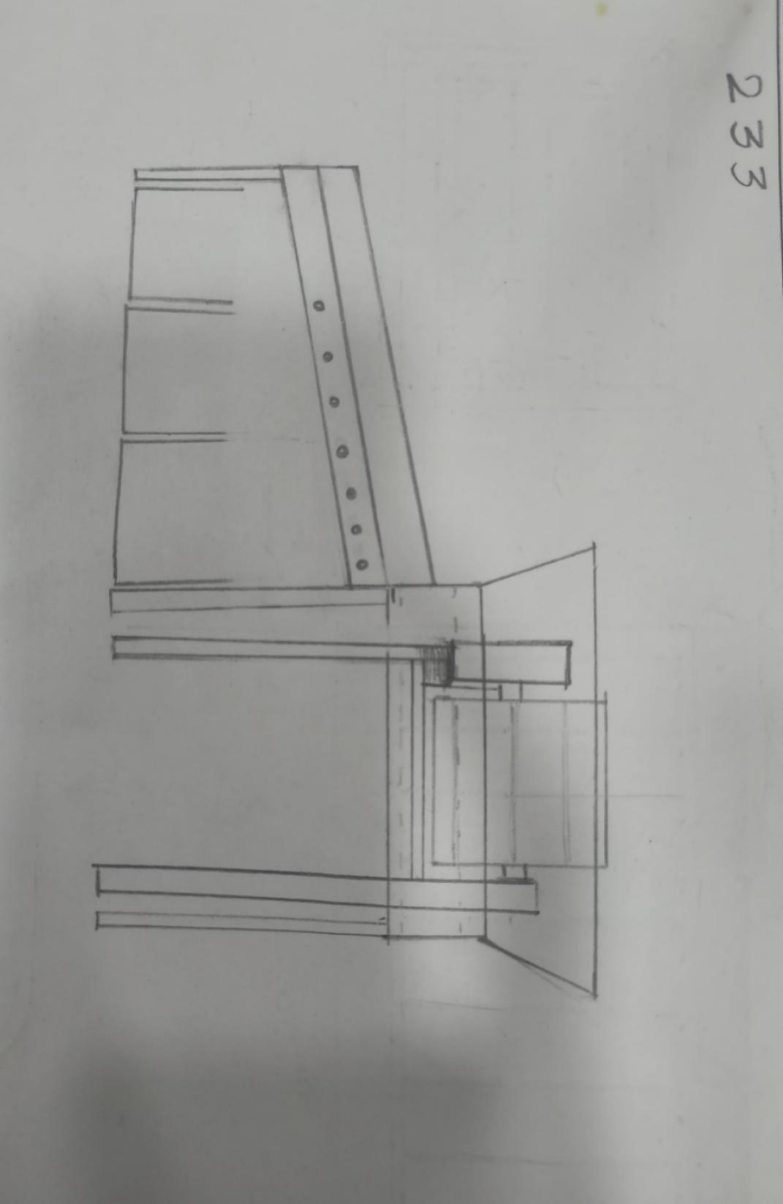

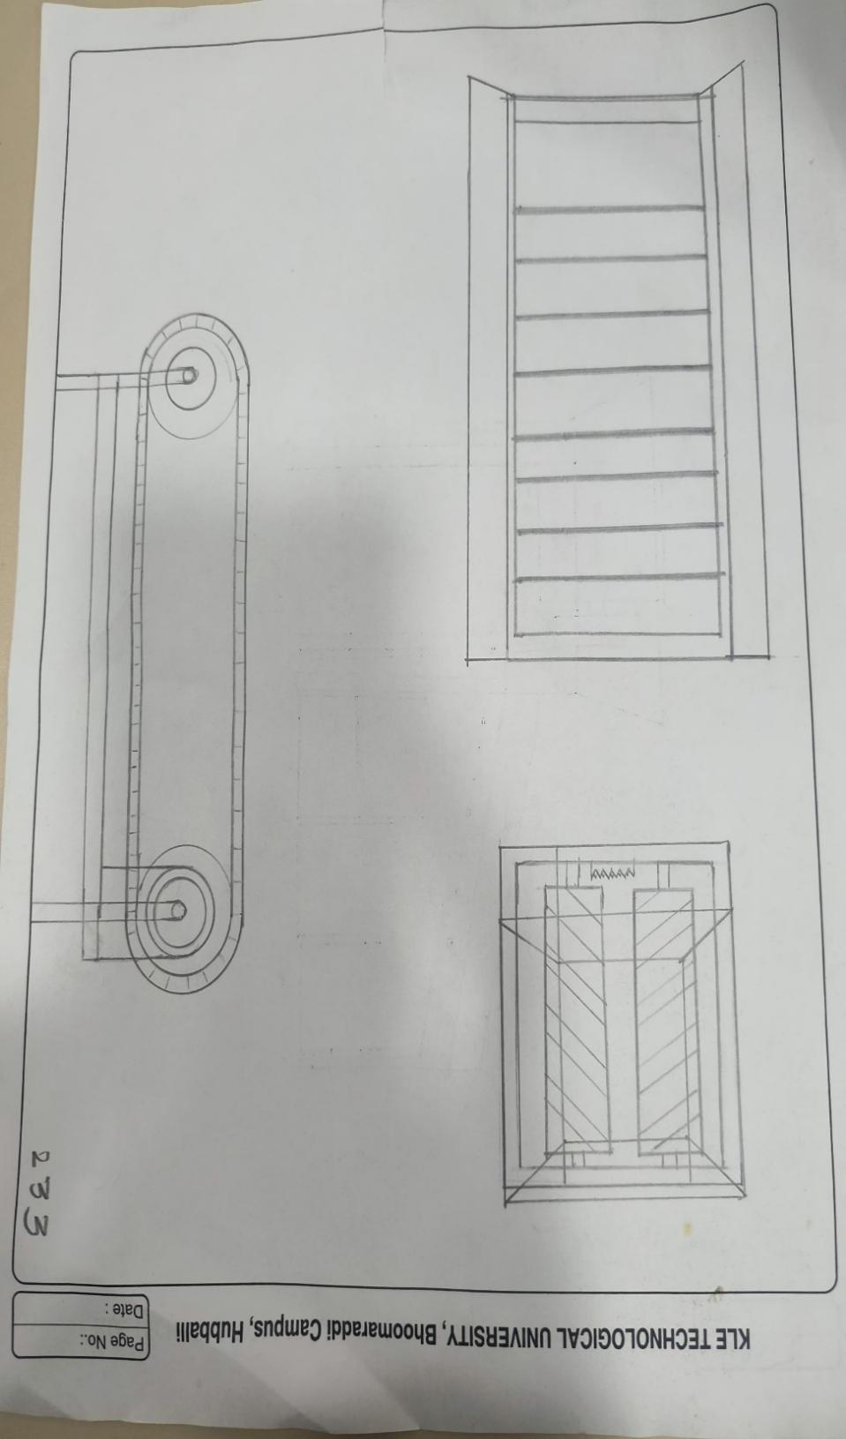

Design No: -3
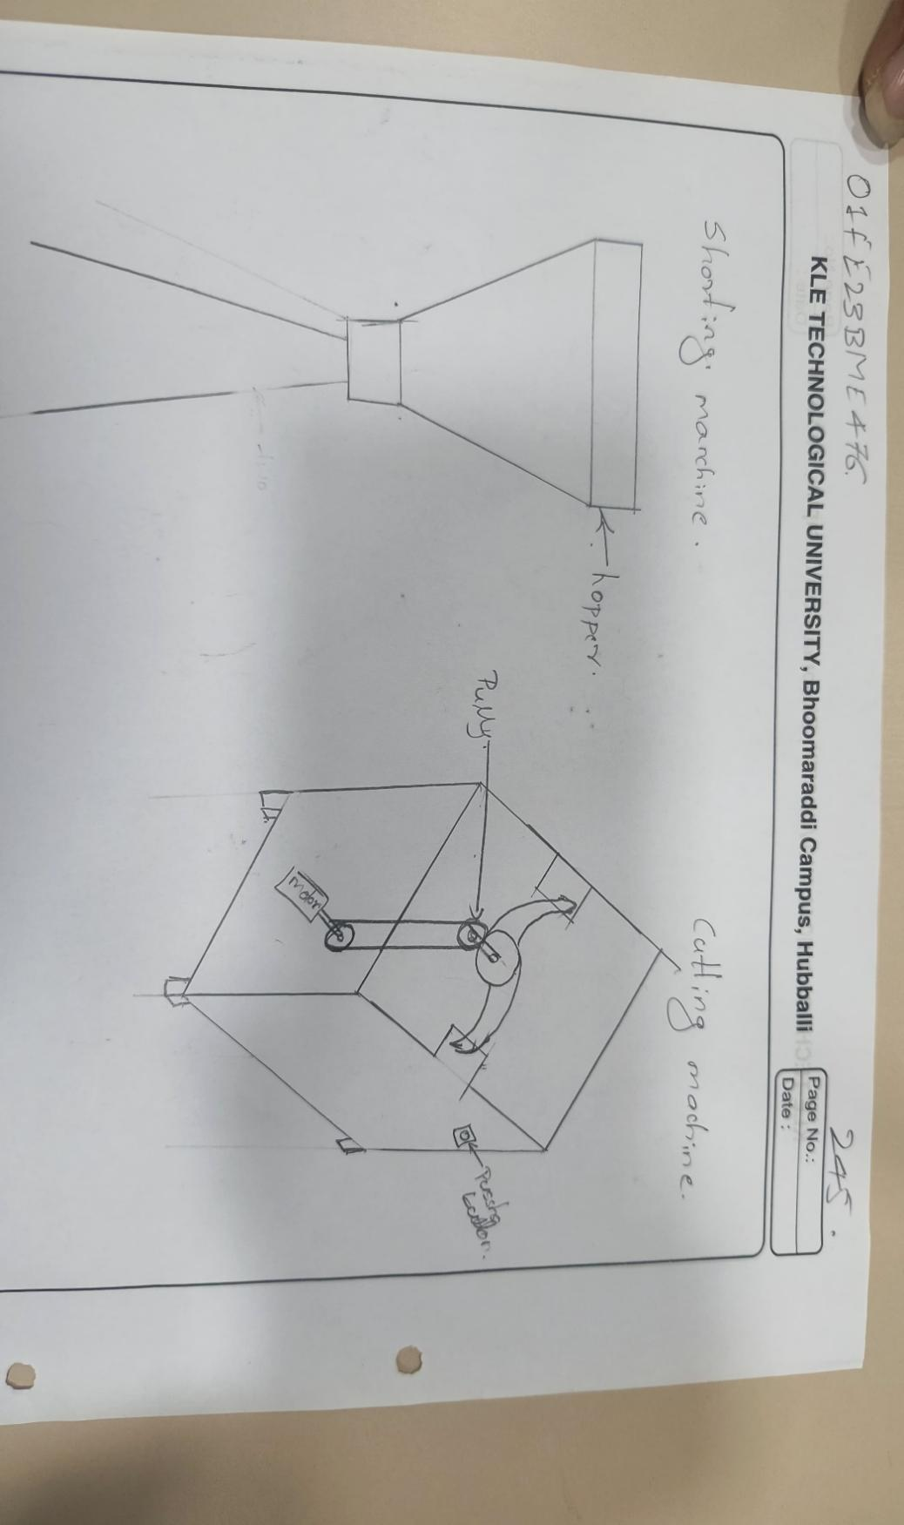

Design No: - 04
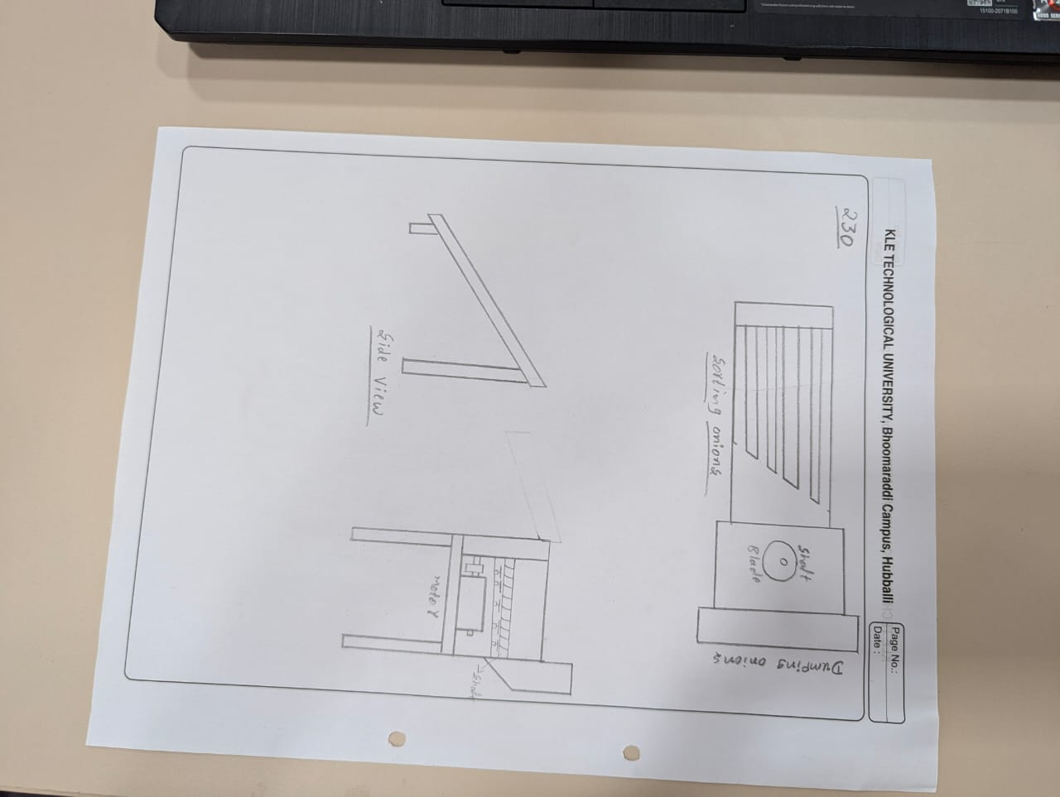

Design No 5:-

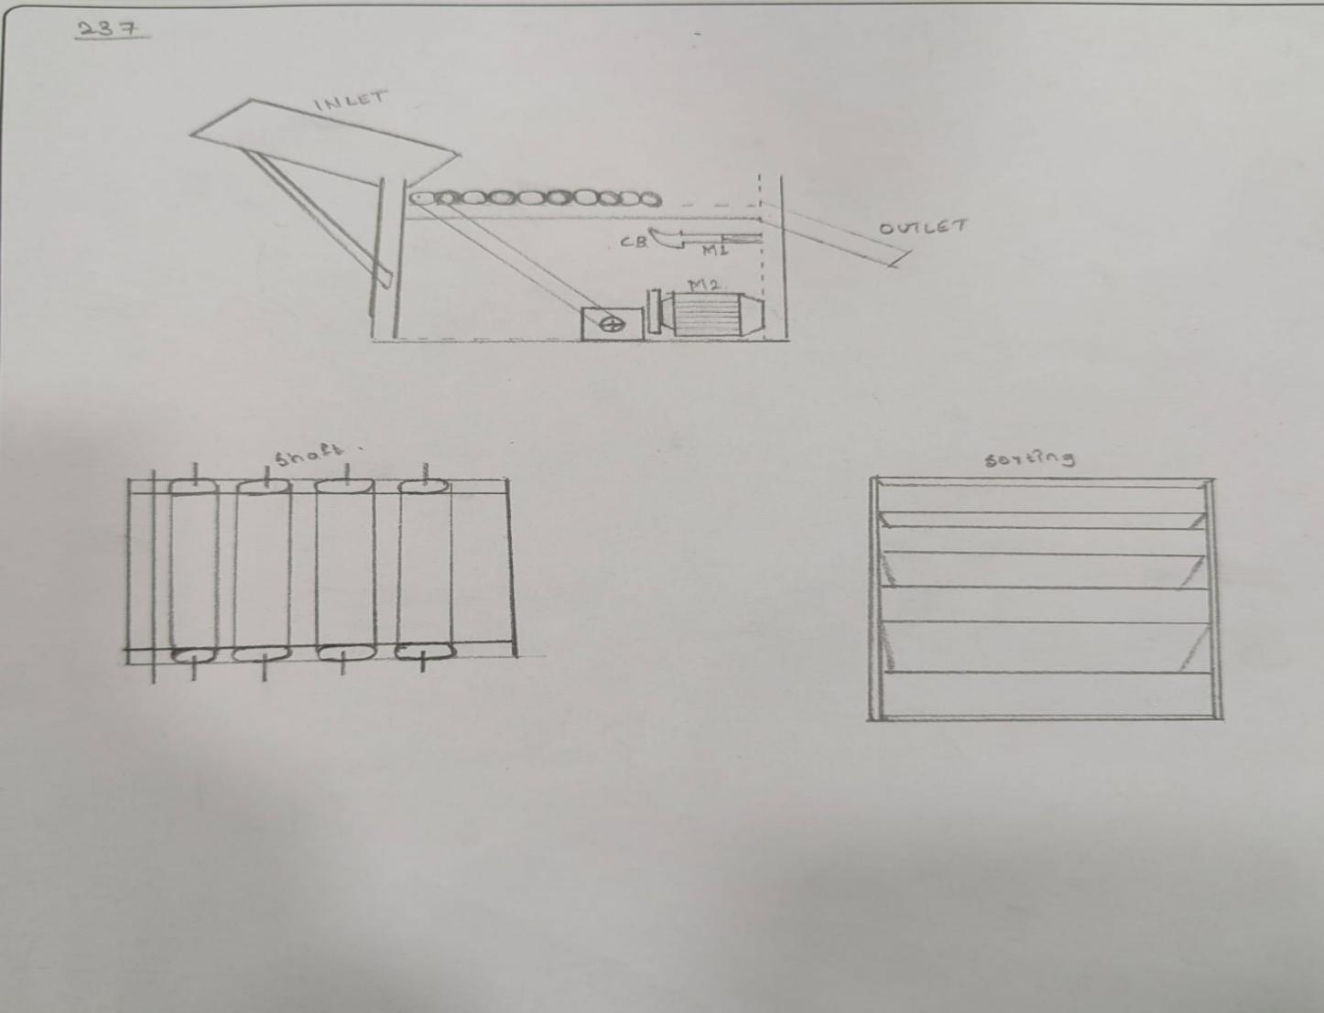

4.4 Selecting Design Alternative (Using Pugh Chart)

Requirements | Weight | Design1 | Design2 | Design3 | Design4 | Design5 | Reference
Cutting Efficiency |  | 6 | 8 | 5 | 5 | 5
Easy of Maintainance |  | 5 | 9 | 8 | 6 | 7
Safety |  | 7 | 10 | 5 | 8 | 6
Accuracy of  Cut |  | 8 | 9 | 8 | 7 | 7
Energy Efficiency |  | 3 | 8 | 7 | 6 | 5
Durability |  | 7 | 10 | 7 | 8 | 8
Feeding system |  | 8 | 9 | 4 | 7 | 6
Waste od management |  | 7 | 10 | 6 | 6 | 8
Sorting of onions |  | 8 | 10 | 8 | 8 | 7
Pluses |  | 4 | 5 | 3 | 3 | 4
Sames |  | 2 | 1 | 2 | 1 | 3
Minuses |  | 3 | 3 | 4 | 4 | 2
Overall Total |  | 1 | 2 | -1 | -1 | 2
Weighted Total |  | 59 | 83 | 55 | 69 | 59
Yes / No |  | No | Yes | No | No | No

5.1 Design Model: -
Rotating Shaft: -
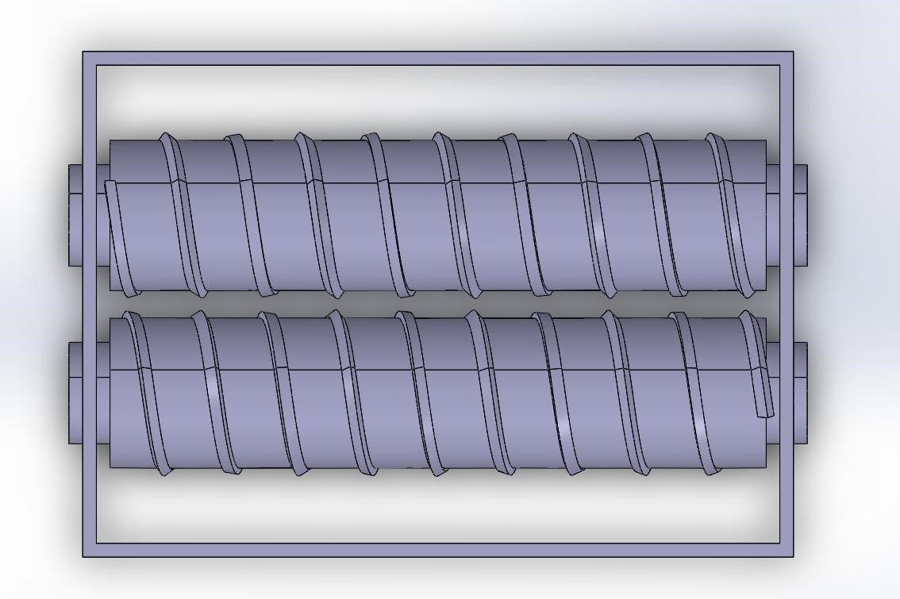

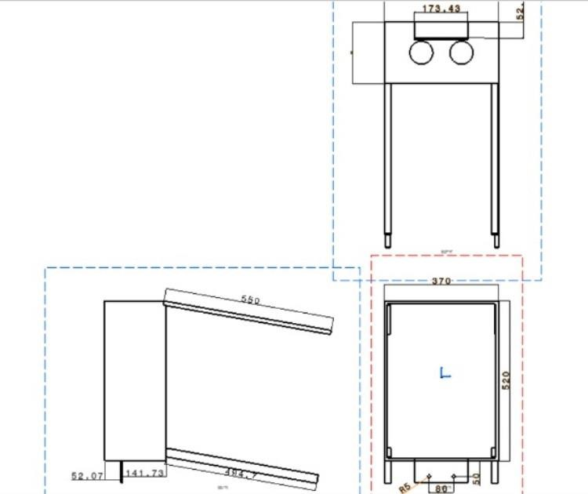

Sorting:

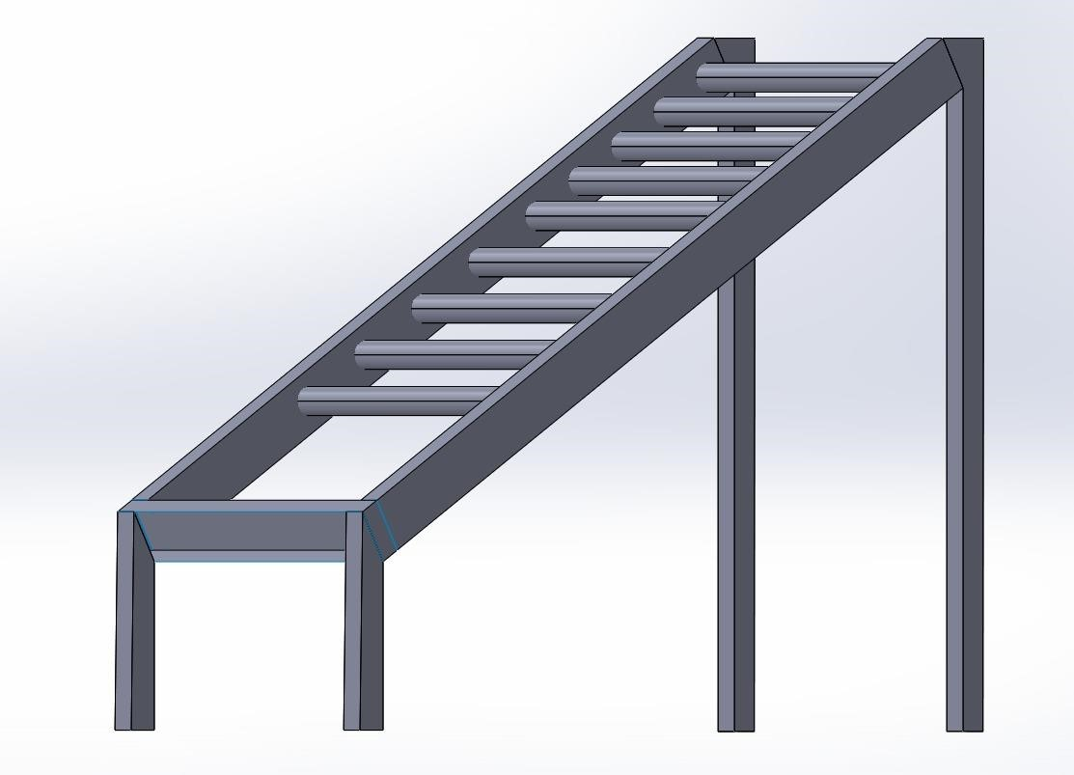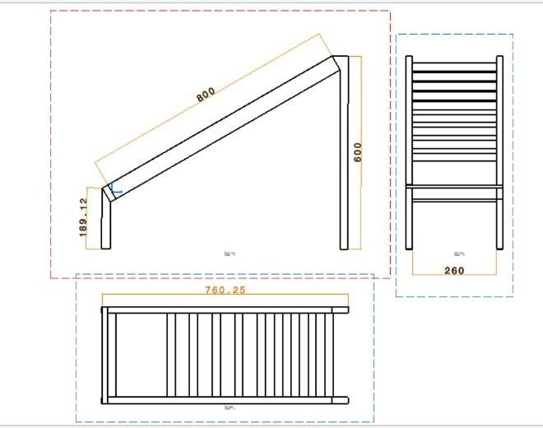

-

Conveyor:

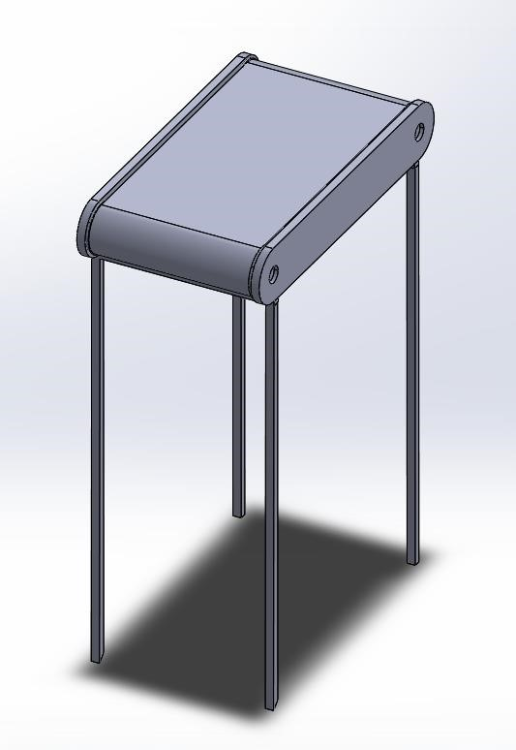
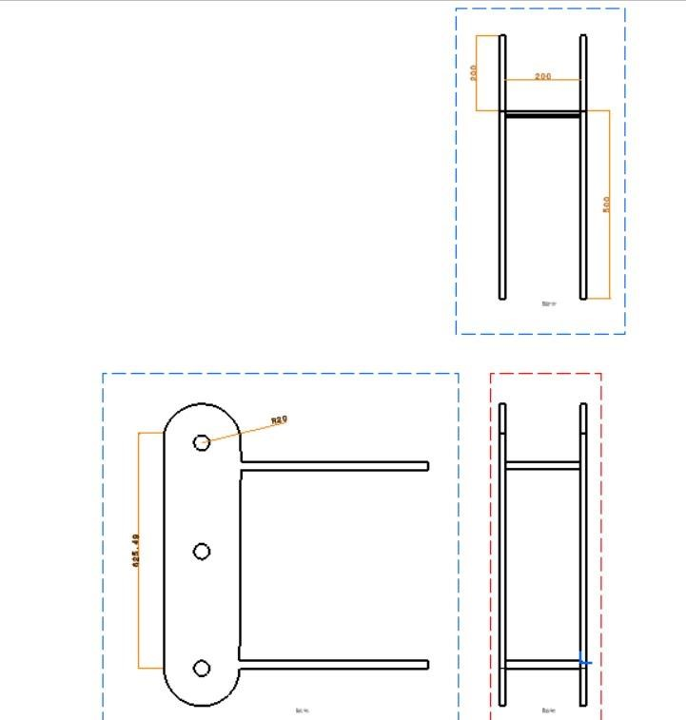

5.2 Assembly Design
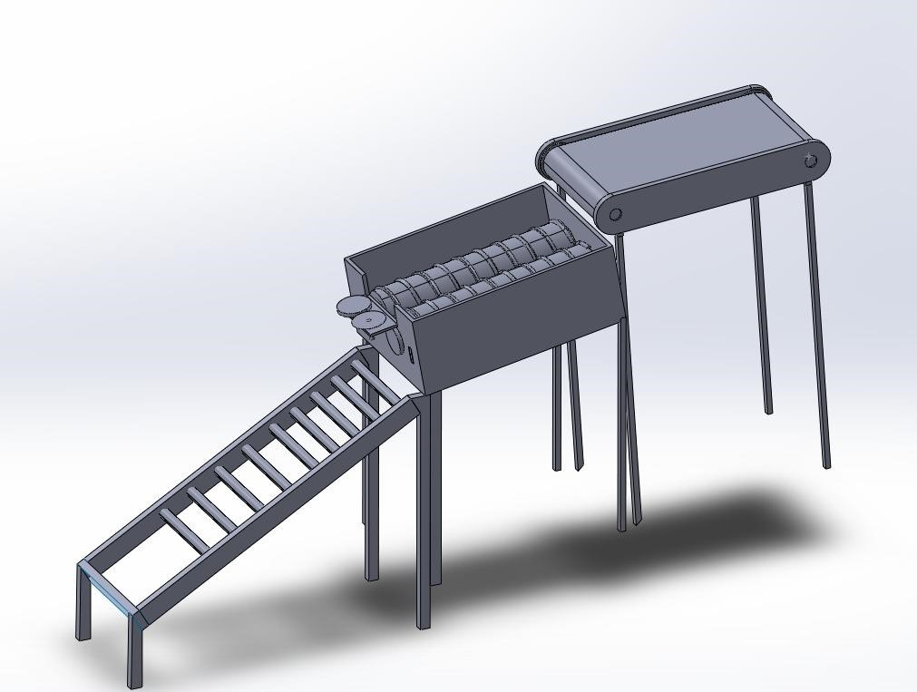
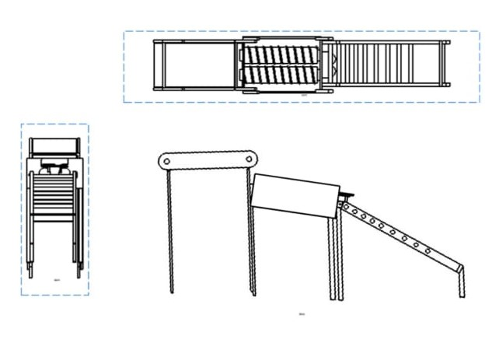
Component | Specification
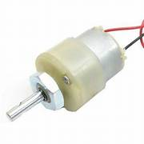 | 1. A 60 RPM DC motor is a low-speed, high-torque motor commonly used in automation and hobby projects.  2. It operates on Direct Current (DC), typically within 6V to 12V voltage range depending on design.  3. It delivers 60 revolutions per minute, making it ideal for applications requiring precise, slow motion.  4. These motors often come with a gearbox to reduce speed and increase torque.
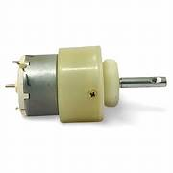 | 1. A 300 RPM DC motor is a medium-speed motor suitable for tasks requiring balanced speed and torque.  2. It typically operates on a voltage range of 6V to 12V, depending on the model.  3. It runs at 300 revolutions per minute*under no-load conditions.  4. A built-in gearbox is often used to achieve the desired RPM while increasing torque.
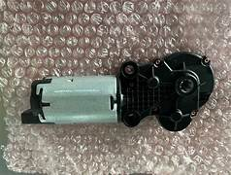 | 1. A 980 RPM DC motor is a high-speed motor commonly used where fast rotational motion is required.  2. It typically operates at 12V, though some variants may support 6V–24V depending on design.  3. Produces 980 revolutions per minute under no-load conditions.  4. It generally has low torque output, making it suitable for lightweight or high-speed applications.

 | 1.Power Rating: Delivers a total output power of 60 watts.  2.Output Voltage: Common outputs include 12V, 15V, or 20V, depending on the device requirements.  3.Output Current: Current varies with voltage—for example, 5A at 12V or 3A at 20V.  4.Input Voltage: Typically supports 100V to 240V AC input, making it suitable for global use.
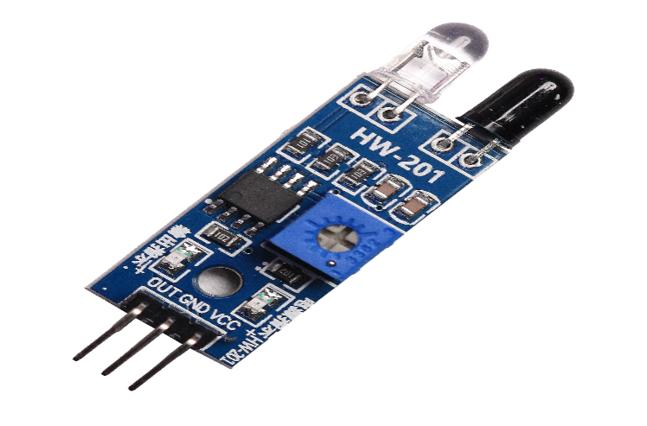 | Detection basis: Infrared sensors detect IR radiation—either emitted (passive) or reflected (active)  Advantages: non-contact, fast response, low power, compact, and cost-effective.  Common uses: in motion sensors, proximity sensors, remote controls, and non-contact thermometers.
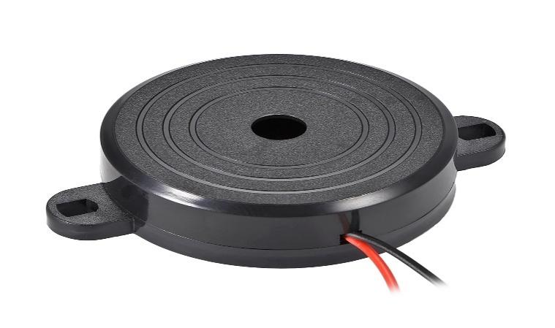 | Purpose: Audio signaling device converting electrical signals into sound for alarms, timers, user feedback, etc.  Types: Mainly electromagnetic/magnetic (coil + magnet) and piezoelectric (uses vibrating ceramic).  Benefits: Compact, low power, easy to integrate, reliable, and cost-effective for simple alert tones.
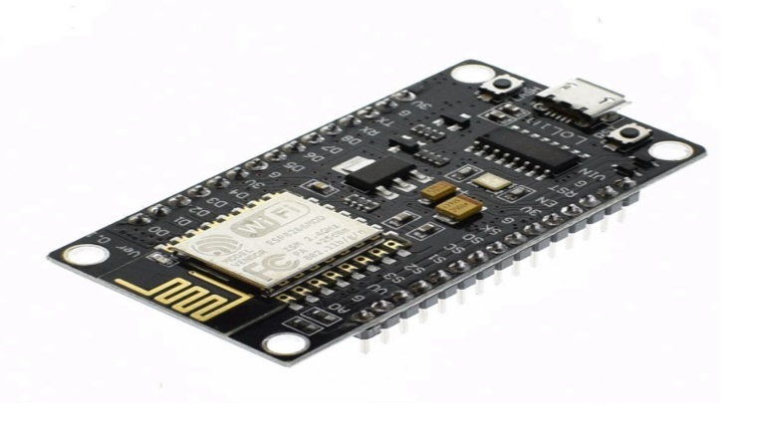 | Wi-Fi + microcontroller in one: Built-in 802.11 b/g/n Wi-Fi + Tensilica 32-bit CPU (80–160 MHz) for standalone IoT tasks  Low-power modes: Sleep, light-sleep, and deep-sleep (µA range) for battery-operated designs.  Rich I/O and protocols: Multiple GPIO pins, ADC, UART, SPI, I²C, PWM + TCP/IP, HTTP, MQTT support

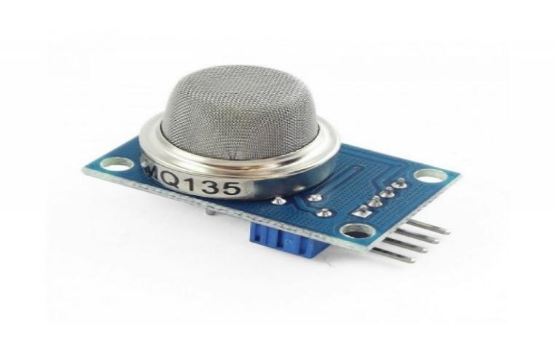 | Detection types: Smoke sensors use ionization (detects small particles from fast flames) or photoelectric (detects larger particles from moldering fires)  Ionization pros/cons: Fast response to flaming fires, but more sensitive to things like cooking smoke .  Photoelectric pros/cons: Better for slow, smoky fires and fewer false alarms (like from steam/toast)

5.4 FEM Analysis
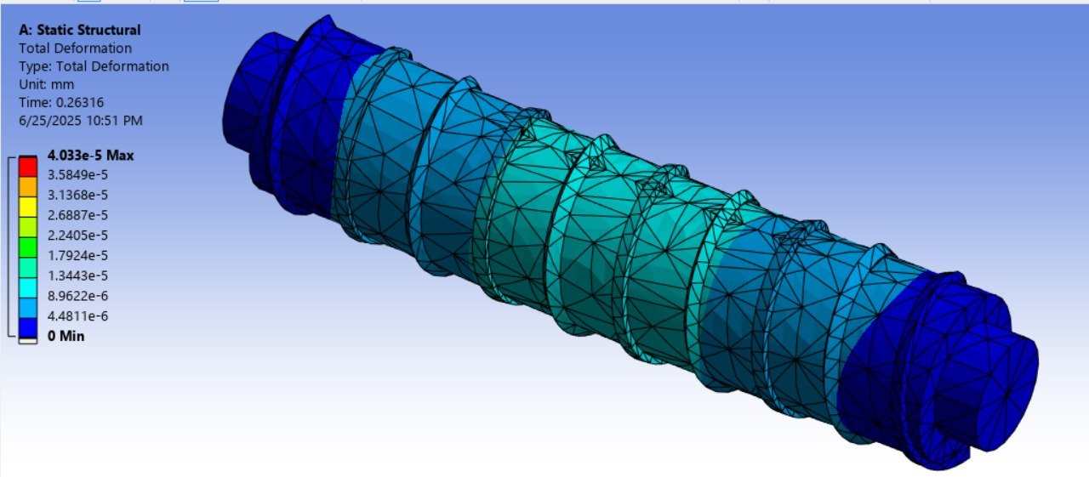
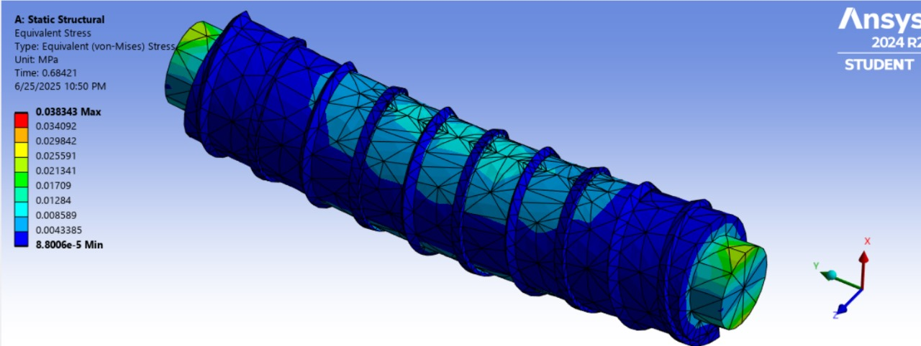

5.3 Design calculation
- Shaft rotating:
    - shaft dia. = 100mm = 0.1m
    - shaft length = 400mm
    - load (say weight of onions) = 60 × 70g = 70g = 0.07kg
    - load on shaft = 0.07kg × 10 = 0.7N
- Torque:
T=P×9550NT = \frac{P \times 9550}{N}T=NP×9550 T=0.2×955040T = \frac{0.2 \times
9550}{40}T=400.2×9550 =47.75 Nm= 47.75 \, Nm=47.75Nm
(Assume Power = 0.2 kW, N = 40rpm)

- Cutting Speed:
V=π×D×NV = \pi \times D \times NV=π×D×N =π×0.1×40= \pi \times 0.1 \times 40=π×0.1×40 V=12.56 m/sV = 12.56 \, m/sV=12.56m/s

- Blade force:
F=τ×AF = \tau \times AF=τ×A τ=shear stress of onion bed (very low estimate, 0.1 MPa)\tau = \text{shear stress of onion bed (very low estimate, 0.1 MPa)} τ=shear stress of onion bed (very low estimate, 0.1 MPa)

.

Phase 6: -
6.1 Prototype Planning: -
# | Material | Properties /Reason for selecting the material | Part Name and  Number
1  2  3 | M S Metal rod, L bar  Acrylic Sheet  Wood | Machinable  High strength  Thermal resistance, max tensile strength  --- | 9  8  1

  - Bill of Materials
Material | size | quantity | prize
MS sheet (hopper) | 0.5mm | 2 | ---
MS sheet | 0.8mm | 3 | ---
Auger drill bit | 30mm diameter  300mm length | 1 | 900
Metal pipe/tube | Inner Dia 30.5mm Outer Dia 36.5mm | 1 | 500
Electrical heating coil | --- | 2 | 1400
bearing | 30mm | 1 | 450
shaft | 75mm diameter 600mm length | 1 | 300
300 rpm DC motor | --- | 2 | 480
Motor drive (PWM)  controller | --- | 2 | 200
12V power supply | --- | 1 | 700
Temperature control  (REX 100) | --- | 1 | 1000
Thermal insulator | --- | 1 | 230
Main switch & wiring | --- | --- | 100
Holder/ support | 120mm long  5mm thick | 4 | ----
Guide rollers | --- | 2 | 300
Nuts, bolts, washers | --- | --- | 50
 |  | Total: - | 6510
 |  | Around | 7000/-

  - Joining techniques/ methods:
# | Joining Method | Material to be joined | Resources required and specifications
1 | Welding | Sheet Metal | 40/80 2 sheet MS
2 | Adhesives | Acrylic | M-SEAL

Flow Chart:
Prepare a tentative flow chart of the series of operations to be followed for prototyping:

[ MS Sheet Metal, MS Rod and L Bar Selection ]
↓
[ Welding and Fabrication ]

↓
[ Shaft and Blade Mounting for Cutting Mechanism ]

↓
[ Manufacturing of Chassis (Hand Cutter, Mallet, Grinder, Welding Equipment) ]

↓
[ Assembly of Shaft, Blades and Chassis ]

↓
[ Testing, Calibration and System Modification ]

Phase 7
7.1 Fabrication Pictures: -
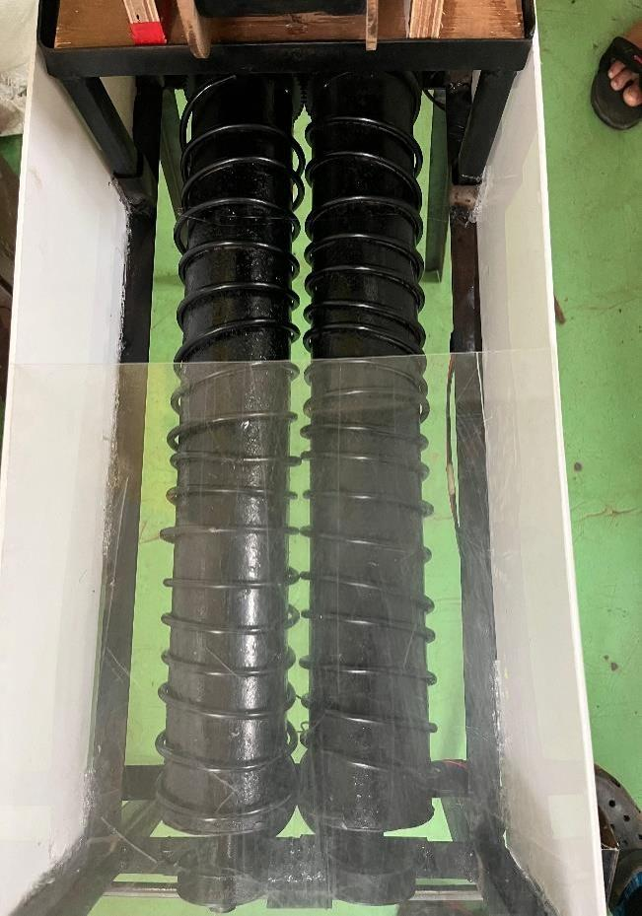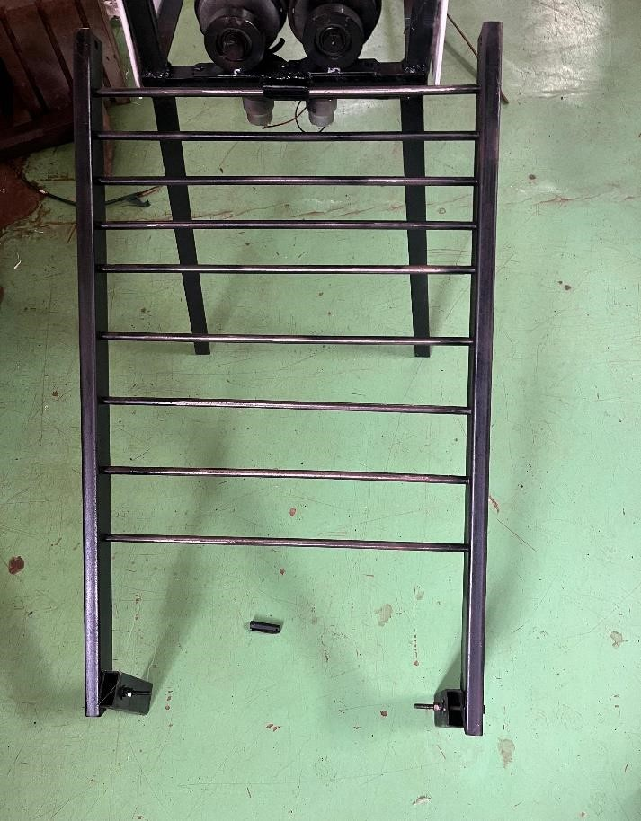

7.3 Conclusion: -
The development of a power-operated onion detopper addresses the critical need for mechanization in post-harvest onion processing. Onion detopping, traditionally a labourintensive and time-consuming task, presents challenges related to inconsistency, labour shortages, and post-harvest losses. The study focuses on designing a compact, efficient, and user-friendly detopper that can be adopted by small to medium-scale farmers.
The machine consists of a feeding chute, a detopping unit with rotating rollers, and collection chutes for both the bulbs and the leaves. The rollers, configured as circular pipes and square tubes rotating in opposite directions, ensure effective leaf cutting while minimizing bulb damage. The structural design emphasizes ease of fabrication, mobility, and adaptability to various onion sizes and types. Results from development and testing indicate that design and operational parameters such as roller speed and slope significantly influence detopping efficiency, capacity, and bulb safety.




